**Top 10 Casual Shirts Every Businessman Needs to Elevate Their Style**

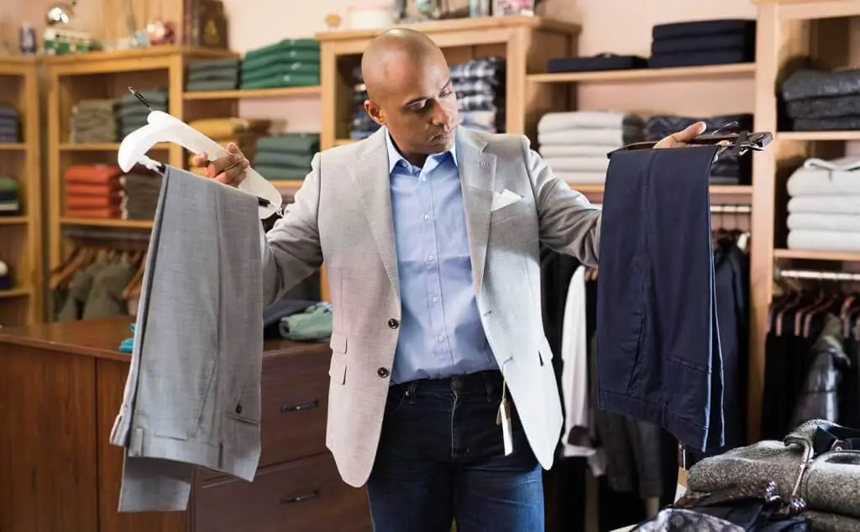

In the fast-paced world of business, maintaining a professional yet approachable image is vital. The modern businessman not only focuses on work performance but also on projecting a style that speaks of confidence and sophistication. A well-curated wardrobe of casual shirts can make all the difference in creating that effortless yet polished look. Below, we present a comprehensive guide to the top 10 casual shirts every businessman should own to elevate their style.

**1. The Classic Oxford Shirt**

The Oxford shirt is a cornerstone of any [custom men shirts](https://www.larimars.com/collections/leather-belts) businessman’s wardrobe. Made from durable and textured Oxford cloth, this shirt bridges the gap between formal and casual attire.

**Why You Need It:**

* Timeless appeal that works for meetings or relaxed outings.
* Versatile styling options—wear it with chinos, jeans, or under a blazer.
* Available in staple colors like white, light blue, and pastel tones.

**Styling Tip:** Roll up the sleeves for a more relaxed vibe or pair it with tailored trousers for semi-formal occasions.

**2. Crisp White Button-Down Shirt**

A white button-down shirt is indispensable for achieving a clean and polished look. It’s a blank canvas that pairs effortlessly with almost any outfit.

**Why You Need It:**

* Offers unmatched versatility in a businessman’s wardrobe.
* Works seamlessly for both casual Fridays and after-work dinners.
* Easily layered with jackets or sweaters.

**Styling Tip:** Accessorize with a leather belt and brown loafers for a cohesive look.

**3. The Patterned Shirt**

Patterned shirts, such as those with checks, stripes, or micro-prints, add a touch of personality to your outfit without overwhelming your overall look.

**Why You Need It:**

* Brings character and style to your ensemble.
* Ideal for less formal business settings and networking events.
* Available in various patterns to suit individual tastes.

**Styling Tip:** Balance the patterns with solid-colored trousers or blazers to maintain a sharp appearance.

**4. The Chambray Shirt**

Chambray shirts provide the denim-like aesthetic without the weight, making them perfect for casual business settings.

**Why You Need It:**

* Lightweight and breathable, suitable for year-round wear.
* Offers a rugged yet refined look that can be dressed up or down.
* Complements earthy tones and neutral shades.

**Styling Tip:** Pair with beige chinos or dark jeans for a smart-casual appearance.

**5. The Linen Shirt**

For warmer climates or summer months, the linen shirt is an excellent addition to your wardrobe. Its airy texture keeps you comfortable while exuding effortless elegance.

**Why You Need It:**

* Provides breathability and comfort in hot weather.
* A stylish choice for outdoor business events or informal gatherings.
* Available in soft, neutral tones or vibrant pastels.

**Styling Tip:** Tuck it into tailored shorts for a relaxed summer look, or pair it with lightweight trousers.

**6. The Polo Shirt**

While technically not a button-down, the polo shirt deserves mention for its blend of sophistication and casual charm.

**Why You Need It:**

* A go-to option for casual business outings.
* Comfortable and stylish, with just the right amount of formality.
* Comes in various materials like pique cotton and jersey for different occasions.

**Styling Tip:** Layer with a lightweight blazer for a business-casual vibe.

**7. The Flannel Shirt**

For colder months, a flannel shirt provides warmth and style. Its soft texture and classic patterns make it a staple for casual yet professional dressing.

**Why You Need It:**

* Combines functionality with a laid-back aesthetic.
* Perfect for casual Fridays or outdoor business retreats.
* Pairs well with denim or neutral-toned chinos.

**Styling Tip:** Leave it unbuttoned over a plain white tee for a relaxed yet intentional look.

**8. The Denim Shirt**

A denim shirt is a rugged yet versatile option that adds an edge to your wardrobe. Whether dark or light wash, it’s a smart choice for business casual attire.

**Why You Need It:**

* Works as a standalone shirt or a layering piece.
* Pairs well with chinos, khakis, or even other shades of denim.
* Adds a modern and slightly rebellious touch to your outfit.

**Styling Tip:** Avoid pairing it with matching denim to prevent a monotonous look. Opt for contrasting trousers instead.

**9. The Mandarin Collar Shirt**

For businessmen seeking a minimalist yet trendy option, the Mandarin collar shirt is a must-have. Its clean design eliminates the need for ties, making it a fresh alternative to traditional shirts.

**Why You Need It:**

* Offers a contemporary look that’s perfect for modern business settings.
* Pairs effortlessly with tailored trousers or slim-fit chinos.
* Works well in both neutral and bold colors.

**Styling Tip:** Wear it tucked in for a professional vibe or untucked for a casual outing.

**10. The Printed Statement Shirt**

For those looking to make an impression, a printed statement shirt adds flair and individuality to your outfit.

**Why You Need It:**

* Allows you to express personal style in creative ways.
* Ideal for networking events or casual office parties.
* Available in bold prints like florals, geometric patterns, or abstract designs.

**Styling Tip:** Tone down the rest of your outfit by pairing it with muted trousers or a solid blazer.

**How to Care for Your Casual Shirts**

To ensure your shirts remain stylish and durable, proper care is essential.

* **Wash Carefully:** Follow label instructions and separate light and dark colors.
* **Iron Properly:** Use appropriate heat settings for the fabric type.
* **Store Strategically:** Hang your shirts to maintain their shape and avoid wrinkles.

**Final Thoughts**

A well-curated collection of casual shirts can transform your wardrobe and elevate your business style effortlessly. By investing in these versatile options, you ensure that you’re prepared for any occasion, whether it’s a casual Friday, a networking event, or an informal client meeting. Remember, style is an extension of your personality—let your shirts speak volumes about your confidence and professionalism.