**How to Download Geometry Dash 2.206 APK with All Levels Unlocked**

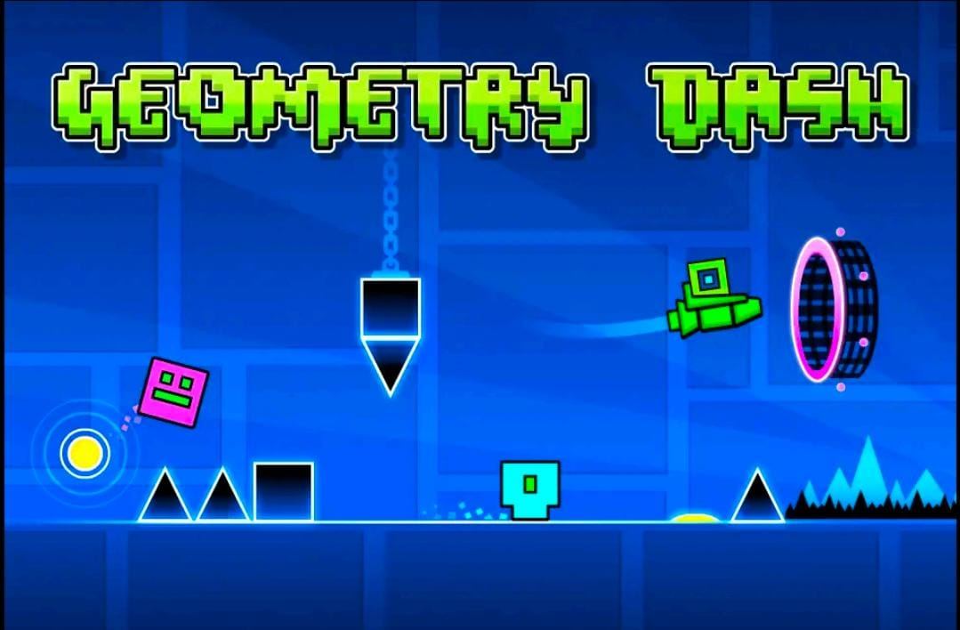

Geometry Dash has long been a go-to game for players who crave intense, rhythmic platforming. With the release of **Geometry Dash 2.206**, the game now offers even more excitement, thanks to new features and smoother gameplay. But for those looking to jump straight into the action, downloading the **Geometry Dash 2.206 APK with all levels unlocked** provides a unique, unrestricted experience. Here’s a comprehensive guide on downloading and setting up this APK to give you full access to everything Geometry Dash has to offer.

**What Is Geometry Dash 2.206 APK with All Levels Unlocked?**

Geometry Dash 2.206 APK with all levels unlocked is a [geometry dash free](https://geometerydashh.com/geometry-dash-lite/) modified version of the official game that offers complete access to every level, customization option, and feature without the need to progress through the game. By downloading this APK, players can:

* **Unlock all official levels** immediately, from the easiest to the hardest
* **Access every custom level** and level editor tools
* **Customize icons, characters, and colors** with all available options
* **Use all power-ups and abilities** without limitations
* **Play every soundtrack** and song associated with each level

This version is designed for fans who want to explore every aspect of Geometry Dash without grinding through each level.

**Why Download Geometry Dash 2.206 APK with All Levels Unlocked?**

Having Geometry Dash 2.206 APK with all levels unlocked enhances the player experience by giving immediate access to every element of the game. Here’s why it’s a great option:

1. **Instant Access to Every Level** – Dive right into any level, even the toughest ones, without waiting.
2. **Complete Customization** – Modify your character with every available icon and color combination.
3. **Unlocked Soundtracks and Songs** – Enjoy the full music experience that makes Geometry Dash unique.
4. **Perfect for Practice** – With all levels available, you can practice specific levels as much as you like.

**How to Download Geometry Dash 2.206 APK with All Levels Unlocked**

Downloading the Geometry Dash 2.206 APK file requires following a few specific steps to ensure you’re accessing a safe and compatible version. Here’s a step-by-step guide on how to download and install the APK on your Android device:

**Step 1: Prepare Your Device for APK Installation**

By default, Android devices restrict installations from sources outside the Google Play Store. You’ll need to change this setting to allow the APK installation:

1. Open **Settings** on your Android device.
2. Scroll to **Security** or **Privacy** (depending on your device model).
3. Toggle on **Unknown Sources** to enable installation from non-Play Store sources.

**Step 2: Find a Trusted Source for the Geometry Dash 2.206 APK**

When downloading APK files, it’s essential to find a trustworthy source to avoid downloading malicious or fake files. Look for reputable APK sites or official forums that host the **Geometry Dash 2.206 APK with all levels unlocked**. Here are some tips for finding a safe source:

* Choose well-known APK download websites, like APKMirror or APKPure.
* Verify the file name and version to ensure it’s the correct **2.206 version with unlocked levels**.
* Check user reviews or comments if available, as they can indicate if the file is safe.

**Step 3: Download the Geometry Dash 2.206 APK**

Once you’ve found a reputable source, locate the download link for the **Geometry Dash 2.206 APK with all levels unlocked**. Make sure your device has sufficient storage, and download the APK file to your device.

**Step 4: Install the APK on Your Device**

1. After downloading, go to your device’s **Downloads** folder or open the notification bar and click on the APK file.
2. Follow the on-screen prompts to install the APK.
3. Once installation is complete, open the game to start enjoying Geometry Dash with all levels unlocked.

**Step 5: Start the Game and Customize Your Experience**

With the APK successfully installed, you now have full access to every feature in Geometry Dash 2.206. Explore all levels, customize your character, and try out every soundtrack and level editor tool right from the start.

**Tips for Playing Geometry Dash 2.206 with All Levels Unlocked**

Once you’ve installed the unlocked APK, make the most of your experience with these tips:

**1. Familiarize Yourself with the Gameplay**

If you’re new to Geometry Dash, start with the lower-difficulty levels, such as *Stereo Madness* and *Back on Track*, to get comfortable with the game’s controls and rhythm-based gameplay. Once you’re ready, try your hand at the more challenging levels like *Deadlocked* and *Theory of Everything*.

**2. Experiment with Custom Levels**

One of the biggest advantages of the 2.206 version with everything unlocked is access to user-generated content. Browse the level editor and community levels, where you’ll find an endless variety of player-made stages. These levels can range from beginner-friendly to extreme difficulty, giving you ample opportunities to challenge your skills.

**3. Take Advantage of Practice Mode**

Geometry Dash has a built-in **Practice Mode**, which is especially useful for levels with high difficulty. With the unlocked APK, you can set checkpoints at any point in a level, allowing you to practice difficult sections without having to restart. This mode is an excellent way to learn the layout of each level and improve your reaction time.

**4. Sync Your Jumps with the Music**

One unique aspect of Geometry Dash is its music-based gameplay, where jumps and obstacles often align with the rhythm. Play with sound on and sync your movements with the beat to anticipate upcoming jumps and hazards.

**5. Use Icon Customization to Your Advantage**

With all customization options unlocked, choose icons and colors that stand out against level backgrounds. This visual customization can make it easier to keep track of your character, especially in high-speed or visually complex levels.

**Frequently Asked Questions (FAQ)**

**Is the Geometry Dash 2.206 APK Free?**

Yes, many sources offer the APK for free. However, always verify the credibility of the download site to avoid fake or harmful files.

**Will I Receive Updates with the Unlocked APK?**

Unlocked APKs don’t typically support automatic updates. To get the latest features, you’ll need to download new versions manually as they become available.

**Is It Safe to Use the Unlocked Geometry Dash 2.206 APK?**

The unlocked APK is generally safe if downloaded from a reputable source. To ensure your device’s safety, avoid APKs from unknown sites and install antivirus software to protect against potential threats.

**Does This APK Work Offline?**

Yes, Geometry Dash can be played offline, making it perfect for gaming on the go without needing an internet connection.

**Is It Compatible with All Android Devices?**

Geometry Dash 2.206 APK should be compatible with most modern Android devices. However, performance may vary depending on your device’s specifications and the APK version.

**Final Thoughts on Downloading Geometry Dash 2.206 APK with All Levels Unlocked**

Geometry Dash 2.206 APK with all levels unlocked is the ultimate way to experience everything this iconic platformer has to offer. By following the steps in this guide, you’ll be able to download, install, and start playing the game with unrestricted access to every level, character customization, and feature. Take full advantage of the unlocked version, explore the vast community content, and immerse yourself in one of the most rhythmically engaging platform games out there.